Types of ASN
# Source: AI Source: Provided by: [Data Path: Persons Table -> ID Column: 1, Name_En Column: Motasem Essam] -> From: [ChatGPT] on [1/16/2026]
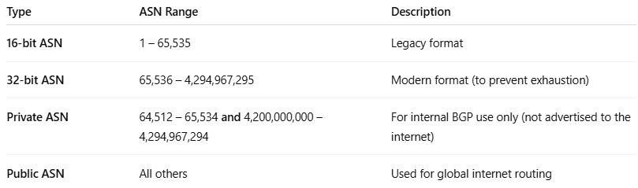

Type | ASN Range | Description
16-bit ASN | 1 – 65,535 | Legacy format
32-bit ASN | 65,536 – 4,294,967,295 | Modern format (to prevent exhaustion)
Private ASN | 64,512 – 65,534 and 4,200,000,000 – 4,294,967,294 | For internal BGP use only (not advertised to the internet)
Public ASN | All others | Used for global internet routing

